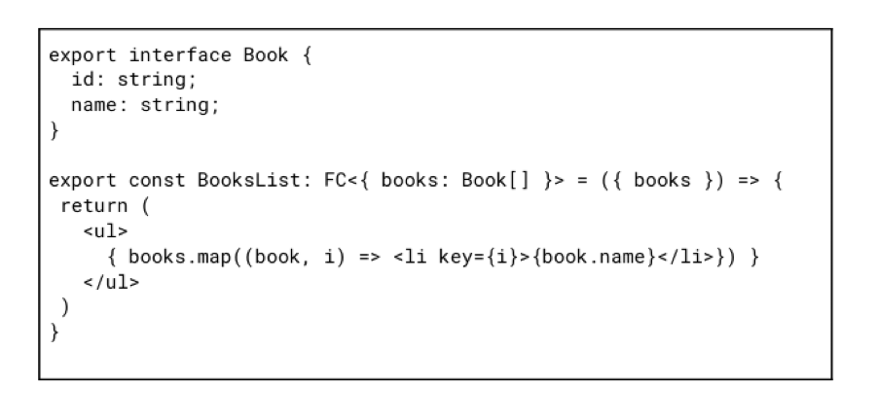

Review following code snippet and answer questions:

1. What’s wrong with this code snippet?
2. How can we improve it?
3. Are there any cases when this code can be used with no modification?

1. In this example, for each element of the list, an identifier from the map method is used. The index problem occurs every time the array changes. React doesn’t understand which element was added, removed, or reordered because the array index is set for each render based on the order of the elements in the array.

2. Use any unique array field as key. In this situation, we can pass book.id to key prop.

3. We can use an index if the list is static and won’t be changed, filtered or sorted.